**Personal portfolio 2**

In release 2, I have done the following jobs:

1. I created a policy page, the file title is policy.html.

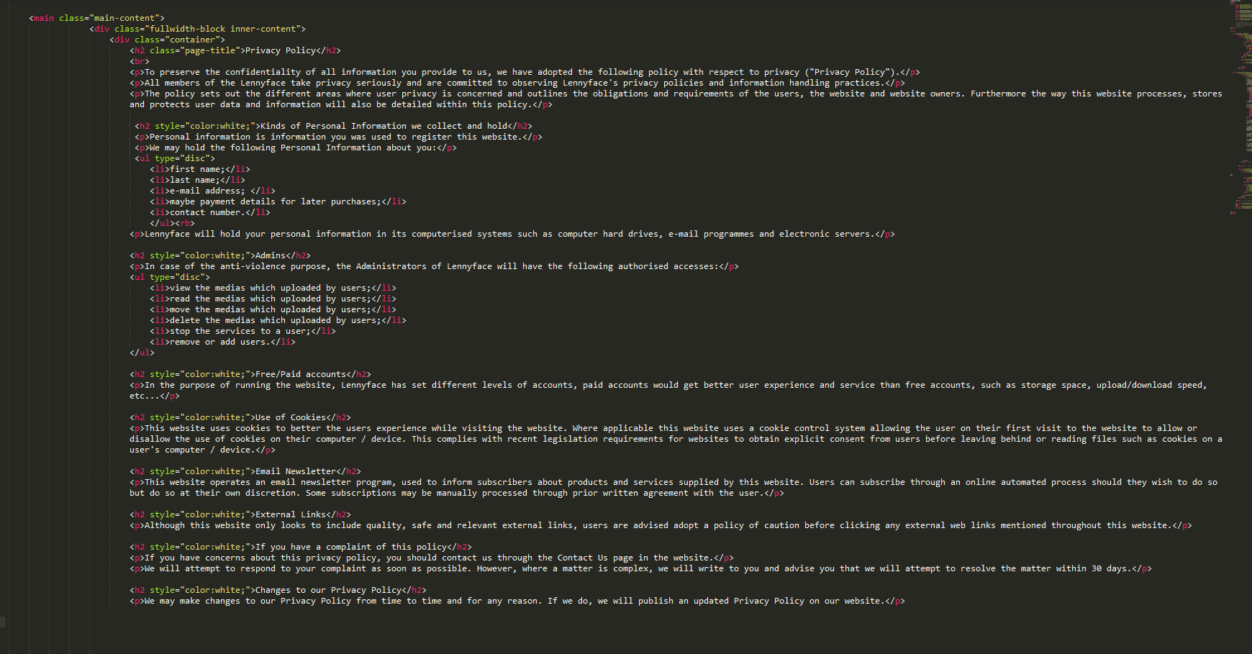

This is a simple but important page. This page contains the policies and agreements that users have to agree them before register to this website.

And then I make a little change of the <href> code in registration.php.

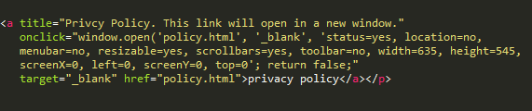

This piece of code will give “privacy policy” a link to a pop up window of the policy page.

1. I have created a sprint plan of sprint 4. The reason to make this plan is to let everyone know what we should do and how many hours we need.

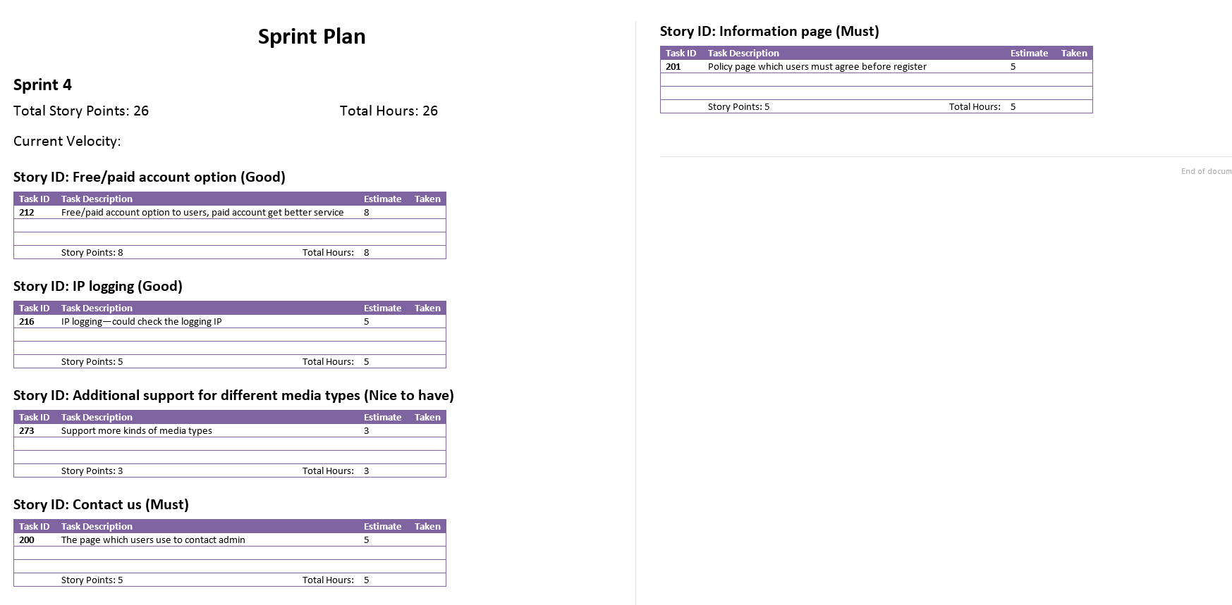

1. I have contacted with Andy (our designer) and David (our clients’ group’s designer). We regularly exchange our ideas and opinions about the website design. We have each other’s phone number and email address.
2. I sometimes help Andy with the logo design, he designs and I make it out by computer. Those pic are not been used.